CHAPTER THREE
METHODOLOGY

3.1 Adopted Methodology
Agile Software Development methodology was chosen for the design and implementation of Crypto-Tax NG. Agile Software Development methodology is an approach to developing software iteratively and incrementally that places great emphasis on adaptability, continuous delivery, and collaboration at all levels of software development life cycle (Sommerville, 2016). In contrast to the classical Waterfall Model that mandates a very linear sequential progression in which one phase cannot begin until the previous one is completed in totality, Agile methodology enables overlapping of multiple phases (Pressman and Maxim, 2020).
The Agile methodology was selected for this project for three specific reasons. First, Crypto-Tax NG spans several independent but deeply interconnected technical modules, which include a FIFO-based calculation engine, a multi-format CSV parsing pipeline, a P2P rate aggregation service, a progressive tax engine, and a PDF report generator. These components required continuous integration testing to ensure that changes to one module did not break others. A fixed, single-delivery model would have made this level of ongoing validation impossible. Second, the regulatory environment that this system operates in changed significantly during the development period, with the Nigeria Tax Act 2025 coming into effect on January 1, 2026, and replacing the Finance Act 2023 flat Capital Gains Tax rate with a progressive Personal Income Tax bracket system. The Agile framework allowed the tax calculation engine to be updated mid-development without requiring the entire project to be redesigned from scratch. Third, the target users of this platform are retail P2P traders who required usable, testable features at each stage of the project, rather than waiting for a completed system at the end. This aligns with the core Agile principle of delivering working software as the primary measure of progress (Beck et al., 2001).
The development process was structured into five iterative sprints. Sprint One covered project setup, database configuration, and user authentication. Sprint Two implemented the wallets module and the CSV upload pipeline with the sniff-and-dispatch parsing engine. Sprint Three built the P2P rate aggregation service, which includes its seven-layer fallback chain from Redis to CoinGecko. Sprint Four implemented the FIFO calculation engine and the dual tax rate logic. Sprint Five covered the PDF report generator and system-wide integration testing. This sprint-based approach follows the Scrum framework as defined by Schwaber and Sutherland (2020).

3.2 Analysis of the Existing System
The existing system selected for analysis is TaxPro Max, the official electronic tax filing and remittance platform operated by the Federal Inland Revenue Service (FIRS) of Nigeria. TaxPro Max was launched in 2021 as a unified digital gateway for federal tax obligations, covering Company Income Tax, Value Added Tax, Pay As You Earn, and Capital Gains Tax. Peter (2023) documented its initial impact on the formal corporate sector and found that the platform drove a 131% surge in Petroleum Profit Tax collection and a 62% improvement in VAT remittance within its first two years of operation, which established it as a genuinely effective tool for registered corporate filers.
Under the Finance Act 2023 and the subsequent FIRS Information Circular issued in 2024, cryptocurrency traders operating in Nigeria are required to declare and remit Capital Gains Tax on profits from digital asset disposals through the TaxPro Max portal. The platform accepts a Tax Identification Number, a calculated net gain figure, and a remittance payment. On the surface, this appears to provide a complete compliance pathway for crypto traders. In practice, however, the platform's architecture exposes a fundamental structural gap when applied to this use case.
TaxPro Max is what Dagunduro et al. (2025) described as a receiver-passive system. The portal is built to accept pre-calculated final figures submitted by professional accountants and large corporate tax departments. It does not contain any built-in engine for reading raw transaction files, applying First-In-First-Out accounting across multiple wallets and exchanges, converting historical P2P rates, or computing the taxable gain itself. A retail P2P trader who logs into TaxPro Max to declare their crypto Capital Gains Tax is presented with a blank input field that demands a final profit number, with zero tools provided to calculate that number. Fabian and David (2021) confirmed this structural limitation in their empirical study of TaxPro Max's adoption impact, finding that improvements in compliance were heavily concentrated among large registered companies that employed dedicated tax compliance staff, while self-employed individuals in the informal sector showed no measurable change in compliance rates after the platform was introduced.
The process flow of TaxPro Max as it applies to a Nigerian crypto trader is illustrated in Figure 3.1 below.
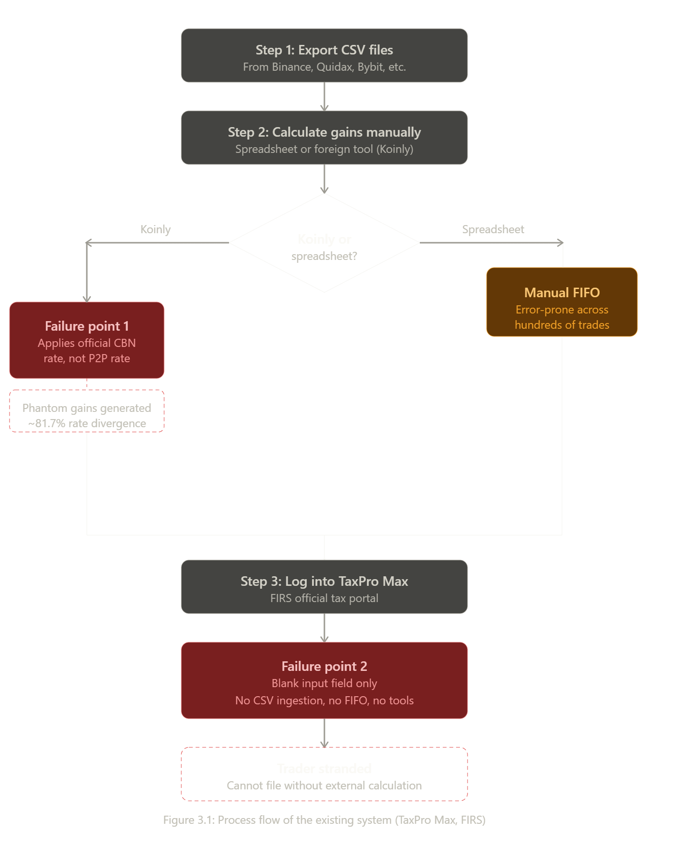
[Figure 3.1: Process flow of the existing system (TaxPro Max, FIRS)]
3.2.1 Limitations or Drawbacks of the Existing System
The following limitations of TaxPro Max are identified in relation to the specific compliance needs of Nigerian P2P cryptocurrency traders:

• No built-in calculation engine: TaxPro Max accepts only pre-calculated tax figures. It does not provide any tool for computing Capital Gains from raw transaction data. A retail trader with hundreds of P2P trades across multiple exchanges has no mechanism within the platform to determine their taxable gain, which means the portal cannot be used without an external calculation system.
• No support for First-In-First-Out accounting: The FIRS mandated FIFO as the required cost basis method for digital assets in its 2024 operational guidelines. TaxPro Max has no FIFO engine, no cost basis tracking, and no lot matching capability. Traders who are required to apply FIFO across years of historical trades cannot do so using the portal alone.
• No P2P rate integration: TaxPro Max does not reference parallel market exchange rates, which are the rates at which Nigerian P2P traders actually conduct their transactions. As documented by Abu and Ohiaeri (2023), Nigerian cryptocurrency transactions are priced at parallel market rates that diverge from the official CBN NAFEM rate by an average of 81.7%. A platform that ignores this divergence cannot produce accurate cost basis or proceeds figures for Nigerian traders.
• No CSV or blockchain data ingestion: The platform cannot read or process the raw CSV files exported by cryptocurrency exchanges such as Binance, Quidax, Luno, or Bybit. Traders must manually extract relevant figures from their transaction history before the platform becomes usable, which introduces a significant risk of human error across potentially hundreds or thousands of transactions.
• No support for retail self-assessment: TaxPro Max was designed for professionally assisted filers, not for individual self-assessment by financially literate but technically unsophisticated retail traders. Templars Law (2024) characterised this as the platform assuming a level of financial and technical sophistication that is simply not representative of the typical Nigerian crypto user.

3.3 Analysis of the Proposed System
Crypto-Tax NG is a web-based cryptocurrency tax compliance system designed specifically for Nigerian P2P traders operating under the regulatory framework established by the Finance Act 2023 and the Nigeria Tax Act 2025. The system resolves every limitation identified in TaxPro Max by providing an end-to-end calculation pipeline that accepts raw exchange CSV files as input and produces a FIRS-compliant tax summary as output, without requiring the user to perform any manual calculations at any stage.
The system authenticates users through a JWT-based authentication flow and supports a custom user model that stores Nigerian-specific fields including Tax Identification Number, phone number, and trader classification. Authenticated users link their exchange accounts through the wallets module, which supports exchange wallets, personal wallets, and hardware wallets. Transaction data is uploaded via a sniff-and-dispatch CSV parsing engine that automatically detects the format of any uploaded file from Binance, Bybit, Quidax, Luno, Roqqu, or Busha and normalises every row into a universal ledger schema. The FIFO calculation engine then processes all normalised transactions in strict chronological order, matches sales against purchases using a queue-based algorithm, and applies the correct tax rate based on the tax year being assessed. For tax years up to and including 2025, the system applies the 10% flat Capital Gains Tax rate established by the Finance Act 2023. For tax year 2026 and beyond, the system applies the progressive Personal Income Tax brackets introduced by the Nigeria Tax Act 2025. The final output is a PDF report formatted for manual entry into TaxPro Max, which includes a gain and loss summary, a FIFO matching table, and a tax liability breakdown.

3.3.1 Preliminary Design
The proposed system uses a client-server architecture consisting of a React 18 web frontend, a Django 5.0 REST API backend, a PostgreSQL 18 relational database, and a Redis caching layer. The frontend communicates with the backend exclusively through authenticated REST API calls using JWT Bearer tokens. The backend exposes all functionality through Django REST Framework viewsets and is organised into six independent Django applications. These applications cover users, wallets, transactions, pricing, calculations, and reports. Each application handles a distinct domain of the compliance workflow and exposes its own URL endpoints.
The P2P rate aggregation service operates through a multi-tiered rate aggregation engine. When a historical rate is required for a given asset and date, the system checks an in-memory cache first, queries the Redis cache, queries the P2PRateHistory database table, calls the Binance historical klines API for the historical USD price, and then falls back to the CoinGecko historical API. It multiplies the resulting USD price by the monthly parallel market rate from the historical lookup table and saves the result to prevent repeated external API calls for the same date. For live USDT/NGN parallel market rates, the engine also queries the Luno Orderbook API which provides real-time NGN pricing directly from active Nigerian exchange orders. This architecture ensures that every rate lookup uses the actual P2P parallel market rate rather than an official CBN rate. This directly addresses the phantom gain problem identified by Bello (2024).
The high-level architectural overview of the proposed system is illustrated in Figure 3.2 below.
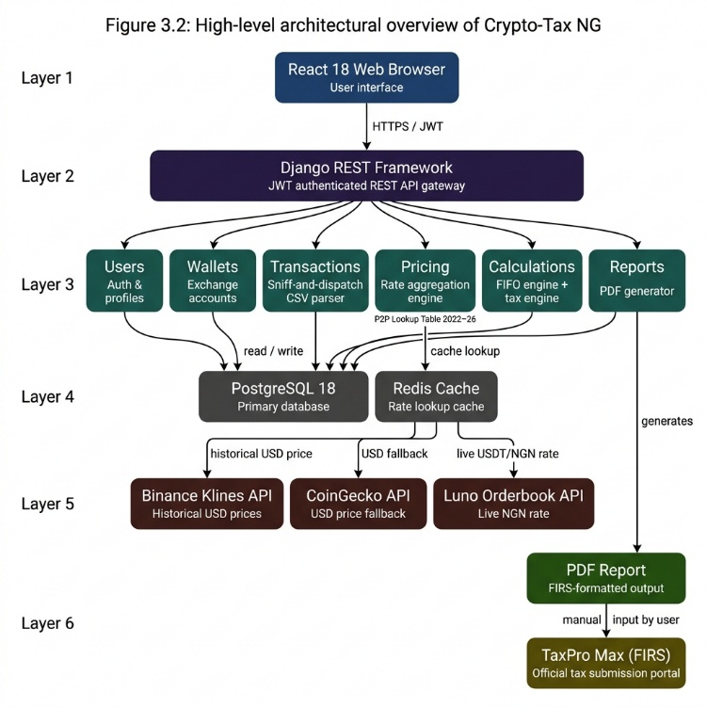

The core processing algorithm operates as follows. A user uploads a CSV file exported from their exchange. The sniff-and-dispatch engine reads the first row of the file, identifies its format by checking for signature column headers, and routes each row to the appropriate sub-parser. The sub-parser normalises the row into the universal Transaction schema and stores it in the database. The pricing service then enriches any transactions that lack NGN values by fetching historical rates through the seven-layer fallback chain. The FIFO engine processes all transactions in chronological order, maintaining a purchase queue per asset, and matches each sale against the oldest available lots until the sale quantity is exhausted. For each matched sale that falls within the requested tax year, a CapitalGain record is created with the proceeds, cost basis, and gain or loss in NGN. The tax engine then aggregates all CapitalGain records for the tax year, applies the appropriate tax rate, and stores the result in a TaxReport object. The report generator reads the TaxReport and produces a PDF document formatted for TaxPro Max submission.

3.3.2 Proposed System Justification
The proposed system is superior to TaxPro Max as a compliance tool for retail crypto traders on four specific dimensions. Table 3.1 below presents a direct feature comparison between TaxPro Max and Crypto-Tax NG.

Table 3.1: Feature Comparison between TaxPro Max and Crypto-Tax NG
Feature | TaxPro Max (Existing) | Crypto-Tax NG (Proposed)
FIFO calculation | Not supported | Full queue-based FIFO engine per asset across all years
CSV data ingestion | Not supported | Sniff-and-dispatch parser for 6 Nigerian exchanges
P2P rate pricing | Not supported | 7-layer fallback chain using parallel market rates
Tax law support | Accepts any submitted figure | Finance Act 2023 (10%) and NTA 2025 (progressive PIT)
Futures handling | Not supported | Realized PnL ingested directly, bypassing FIFO
Report generation | Not supported | FIRS-formatted PDF with FIFO matching table
Target user | Professionally assisted corporate filers | Retail P2P traders conducting self-assessment

Table 3.1 shows that TaxPro Max and Crypto-Tax NG share only a single point of convergence, which is that both systems are involved in the Nigerian Capital Gains Tax compliance process. In every functional dimension that matters to a retail P2P trader, the proposed system provides capability that the existing system does not offer at all. The proposed system does not replace TaxPro Max. Rather, it serves as the pre-processing middleware that generates the calculated figures which TaxPro Max requires as input, thereby completing the compliance workflow that the existing system cannot initiate on its own.

3.3.3 Benefits of the Proposed System
The key benefits of Crypto-Tax NG to its target users and to the broader Nigerian tax compliance ecosystem are as follows:

• Elimination of phantom gains: By using actual parallel market P2P rates for all historical valuations, the system prevents the systematic overstatement of capital gains that occurs when global tools apply official CBN exchange rates to Nigerian trading data. This directly resolves the 61.3% average deviation identified by Bello (2024).
• Full automation of the FIFO process: The system removes the need for any manual calculation by the trader. A user who uploads their exchange CSV files receives a complete, accurate FIFO-based tax report without performing a single manual computation. This addresses the control belief barrier identified by Ajzen (2019) as the primary compliance obstacle for Nigerian crypto traders.
• Multi-exchange support: The system normalises transaction data from six Nigerian-relevant exchanges into a single universal ledger, allowing traders who operate across multiple platforms to produce a consolidated tax return from one system.
• Dual tax law compliance: The system correctly applies the Finance Act 2023 flat 10% Capital Gains Tax rate for historical tax years up to 2025 and the Nigeria Tax Act 2025 progressive Personal Income Tax brackets for the 2026 tax year onwards, ensuring that reports remain legally accurate regardless of the period being assessed.
• Direct TaxPro Max compatibility: The generated PDF report is formatted to allow traders to directly transfer the figures into TaxPro Max for submission, completing the full compliance workflow from raw exchange data to a filed return.

3.4 System Design
The system design for Crypto-Tax NG is presented through Unified Modelling Language (UML) diagrams that capture the structural and behavioural characteristics of the proposed system. The diagrams produced include a Use Case Diagram, an Activity Diagram, and an Entity Relationship Diagram. These diagrams collectively describe how users interact with the system, how data flows through the processing pipeline, and how the underlying database is structured.

3.4.1 Use Case Diagram
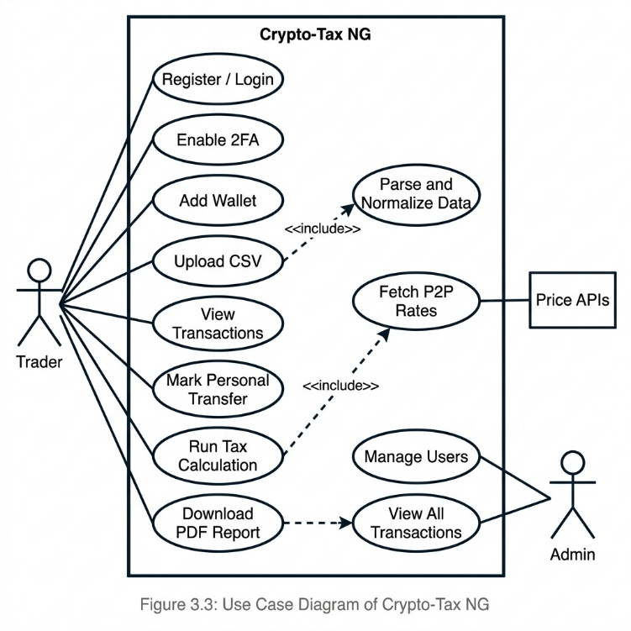
[Figure 3.3: Use Case Diagram of Crypto-Tax NG]

3.4.2 Entity Relationship Diagram
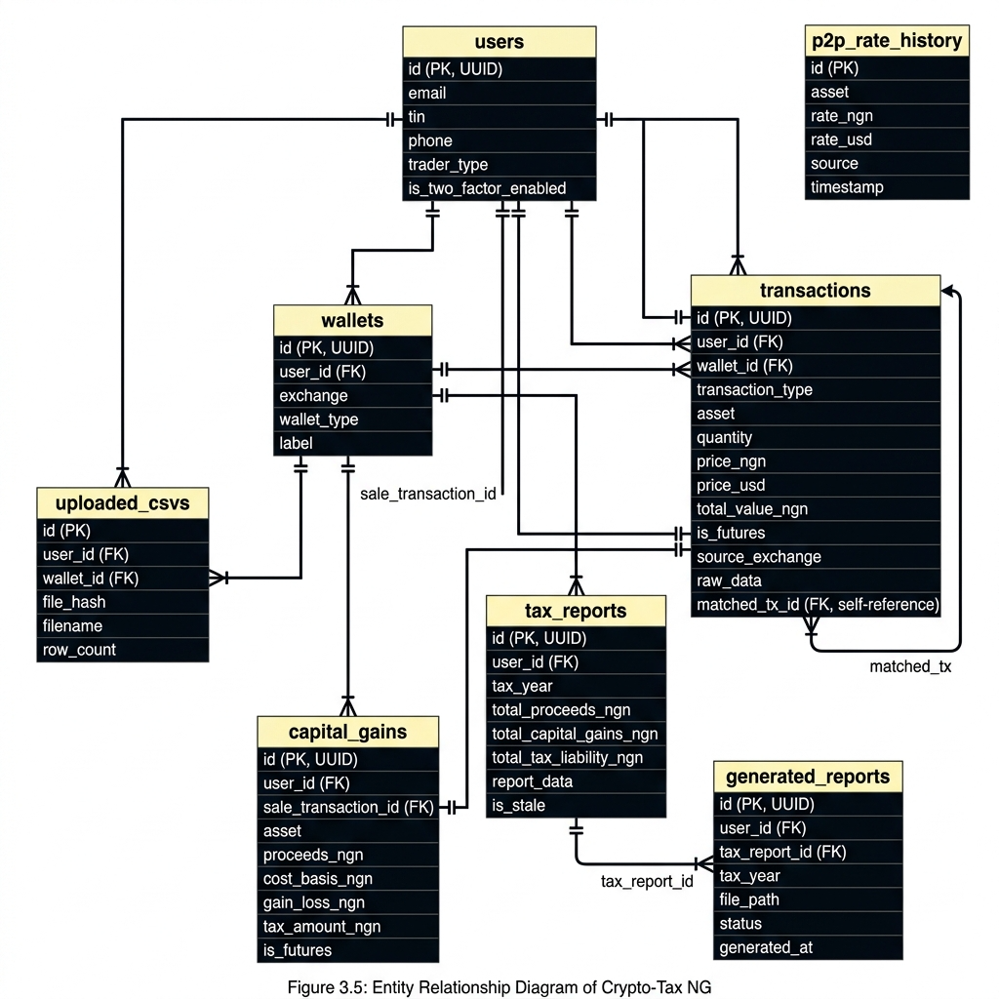
[Figure 3.4: Entity Relationship Diagram of Crypto-Tax NG]

3.5 Database Design
The proposed system uses PostgreSQL 18 as its primary relational database management system. PostgreSQL was selected because of its robust support for decimal precision arithmetic, which is essential for computing tax figures to two decimal places of accuracy across large transaction volumes, its native support for the JSONField data type used to store raw CSV rows for audit trail purposes, and its proven compatibility with the Django ORM through the psycopg2 driver. The database schema is organised around eight core tables as summarised in Table 3.2 below.

Table 3.2: Crypto-Tax NG Database Schema Summary
Table Name | Key Columns | Description
users | id, email, tin, phone, trader_type, is_two_factor_enabled | Stores authenticated user profiles with Nigerian tax fields
wallets | id, user_id, exchange, wallet_type, label, created_at | Stores user exchange and personal wallet accounts
transactions | id, user_id, wallet_id, transaction_type, asset, quantity, price_ngn, price_usd, total_value_ngn, is_futures, source_exchange, raw_data | Stores every normalised transaction imported from exchange CSVs
uploaded_csvs | id, user_id, wallet_id, file_hash, filename, row_count | Tracks imported files by SHA-256 hash to prevent duplicate imports
capital_gains | id, user_id, sale_transaction_id, asset, amount_sold, proceeds_ngn, cost_basis_ngn, gain_loss_ngn, tax_amount_ngn, is_futures, timestamp | Stores FIFO-matched gain and loss records per sale transaction
tax_reports | id, user_id, tax_year, total_proceeds_ngn, total_cost_basis_ngn, total_capital_gains_ngn, total_tax_liability_ngn, report_data, is_stale | Stores the aggregated tax calculation result per user per tax year
p2p_rate_history | id, asset, rate_ngn, rate_usd, source, timestamp | Stores fetched historical P2P exchange rates to prevent repeated API calls
generated_reports | id, user_id, tax_year, file_path, generated_at | Tracks generated PDF reports for download and audit purposes

Table 3.2 shows the eight core tables that form the database schema of Crypto-Tax NG. Each table is designed around a specific domain of the compliance workflow, from user authentication through to final report generation. The transactions table is the most critical table in the schema because it serves as the universal ledger that receives all normalised data from the CSV parsing pipeline and feeds all data into the FIFO calculation engine. The use of a JSONField in the raw_data column of the transactions table ensures that the original CSV row is preserved in full for every imported transaction, which satisfies the audit trail requirement mandated by ISA 2025.

3.6 Input/Output Specification
The input/output specification defines the data that Crypto-Tax NG accepts from users at each stage of the compliance workflow and the outputs it produces in response. Table 3.3 below presents the main input and output requirements for each core system function.

Table 3.3: Input/Output Specification of Crypto-Tax NG
Function | Input | Output
User Registration | Full name, email address, password, phone number, TIN, trader classification | JWT access token, user profile created, redirect to dashboard
User Login | Email address and password | JWT access token and refresh token, user session initiated
Wallet Creation | Exchange name, wallet type, label | Wallet record stored in database, wallet appears in user dashboard
CSV Upload | CSV file exported from exchange, selected wallet ID | SHA-256 duplicate check performed, file parsed by sniff-and-dispatch engine, normalised transactions stored in database
Tax Calculation | User ID and requested tax year | CapitalGain records created for all sales in tax year, TaxReport object saved with total proceeds, cost basis, gains, and tax liability
PDF Report Generation | Tax year selection | Downloadable PDF containing gain and loss summary, FIFO matching table, tax bracket breakdown, and TaxPro Max input values
2FA Setup | TOTP secret confirmation code from authenticator app | Two-factor authentication enabled on user account, trusted device recorded

Table 3.3 shows that every function in the system takes a defined input and produces a verifiable output, ensuring that the compliance workflow is fully traceable from the initial CSV upload through to the final PDF report. The SHA-256 duplicate check on CSV uploads prevents the same file from being imported twice, which addresses a known loophole in self-assessment systems where duplicate imports could artificially inflate cost basis figures and reduce declared tax liability.
3.7 Cost Analysis
The cost analysis for Crypto-Tax NG covers the tools, technologies, and services used in the development and deployment of the system. The majority of the stack relies on open-source frameworks and free-tier cloud services, which kept the initial development cost at a minimum. Table 3.4 below details the cost components for the development and initial deployment of the system.

Table 3.4: Cost Analysis of Crypto-Tax NG Development and Deployment
Component | Tool / Service | Cost
Backend Framework | Django 5.0 with Django REST Framework (open source) | Free
Frontend Framework | React 18 with Tailwind CSS (open source) | Free
Database | PostgreSQL 18 (open source) | Free
Caching Layer | Redis (open source, self-hosted) | Free
PDF Generation | ReportLab (open source Python library) | Free
Authentication | djangorestframework-simplejwt (open source) | Free
Price API (Primary) | Binance klines API (free public endpoint) | Free
Price API (Fallback) | CoinGecko API (free tier, 10,000 calls/month) | Free
Development Environment | Visual Studio Code (free), Windows 11 | Free
Version Control | Git and GitHub (free for public repositories) | Free
Total Development Cost |  | N0.00

Table 3.4 shows that the full development stack for Crypto-Tax NG was assembled entirely from open-source frameworks and free-tier API services, resulting in a total development cost of zero naira. The reliance on widely maintained open-source tools also means that the system does not accumulate software licensing debt and can be extended or modified by future developers without incurring additional tooling costs. The primary cost consideration for a production deployment of the system would be server hosting, which falls outside the scope of this study as the platform is currently deployed in a local development environment.

